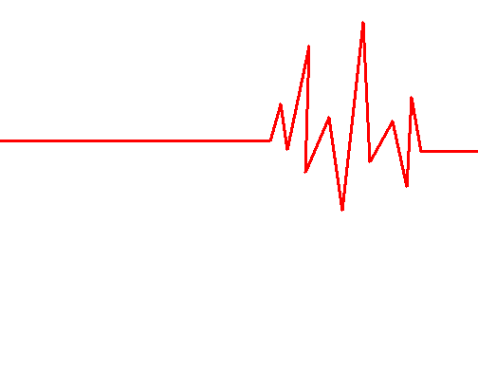

Pulse Watch
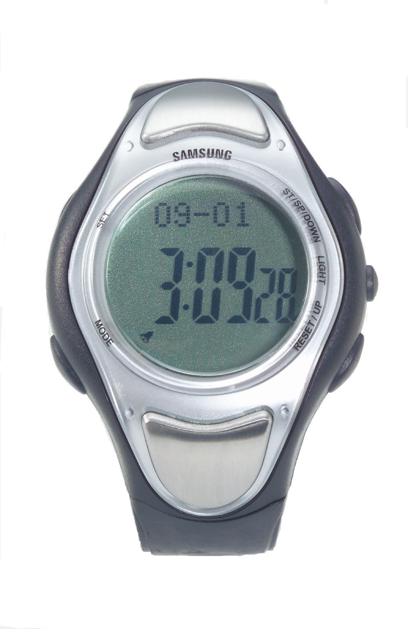

Operation Manual

Thank you for buying this Pulse Watch. To ensure the best performance of the watch, please read this instruction manual carefully.

PRODUCT FEATURES
● Time (12/24 hrs display format)
● Daily alarm
● Stopwatch with 10 lap memories
● Memory recall
● Count-down timer
● Pacer
● Fitness Test
● Zone & Pulse Alert setting
● 30 Pulse Memories
● EL backlight
● Water resistant distance down to 30 meters

BUTTON FUNCTONS

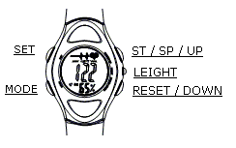This pulse watch includes five buttons: SET、MODE、RESET/UP、LIGHT、ST/SP/DOWN button. Press MODE button, the functions will shift in recycle way: Time – Alarm – Stopwatch – Memory Recall – Count-down - Zone & Pulse alert – Pacer.

TIME MODE

1. Hold SET button for 3 seconds to set your desired time.
2. Press MODE button to shift targets: hour-minute-second-date-month-year-age.
3. Press RESET/UP or ST/SP/DOWN button to increase or decrease digits.
Not release the button can increase or decrease digits quickly.
4. Press SET button again to confirm and return to time mode.

ALARM MODE

In the alarm mode, press Down/Up button to turn it on or off. Icon
indicates alarm is ON. When the alarm is beeping, it will beep for 1 minute until you press any button to stop it.
1. Hold SET button for 3 seconds to set your desired alarm time.
2. Press MODE button to shift targets: hour-minute.
3. Press RESET/UP or ST/SP/DOWN button to increase or decrease digits.
Not release the button can increase or decrease digits quickly.
4. Press SET button again to confirm and return to alarm mode.
STOPWATCH MODE

1. Press ST/SP button to start or stop the stopwatch.
2. When stopwatch is running, press RESET button to split lap memory. This unit can record 10 laps, when the memory number comes to 10; “lap 10” will be flashing.
3. Press RESET to clear all readings and memories when stopwatch is stopped.

MEMORY RECALL MODE
Press UP or DOWN button to recall memories.

COUNT-DOWN TIMER MODE

In count-down timer mode, press RESET/UP button to start or stop it. When it counts down to 0, it will beep for 1 minute; you can press any button to stop it.
1. Press SET button to set your desired time.
2. Press MODE button to shift targets: hour-minute.
3. Press RESET/UP or ST/SP/DOWN button to increase or decrease digits.
Not release the button can increase or decrease digits quickly.
4. Press SET button again to confirm and return to count-down timer mode.

PACER MODE

1. Press RESET/UP button to start or stop pacer.
2. Hold SET button for 3 seconds to enter into the pacer cycle setting.
3. Press RESET/UP or ST/SP/DOWN button to set your desired cycle.
The times Corresponding to 60 seconds are: 30-60-80-100-120-140-160-180-200-240.
4. Press SET button to confirm setting.

FITNESS TEST

This function is to test the recovery of heart beat after some exercises.
1. Put the 2 fingers onto sensing pads. Once the first pulse reading comes out, 60 sec count-down timer will start – Fitness Test.
2. When enter into the Fitness Test, fitness timer will display: 60, 59, 58 … 2, 1.
3. Fitness reading (in percentage) will be shown. The better recovery of heart beat shows larger reading. Generally, we can rate

Fitness Reading (%) | Rating
85 or up | Excellent
75 – 85 | Good
60 – 75 | Fair
40 – 60 | Poor
Below 40 | Very Poor

ZONE & PULSE ALERT
SETTING MODE

1. Hold SET button for 3 seconds to enter into Zone &Pulse alert setting mode.
2. Press RESET/UP or ST/SP/DOWN button to select: P ZONE – F ZONE – H ZONE.

P-Zone: Professional For Sports
80 – 95% Max Heart Rate

F-Zone: Fitness For Gym / Jogging 65 – 80% Max Heart Rate

H-Zone: Healthy For Resting 50 – 65% Max Heart Rate

Max Heart Rate =
220 – Age (pulse / min)
3. Press SET button PULSEAL ON – PULSEAL OFF. Press SET button confirms setting.
4. When start Zone & pulse alert setting mode, the alert icon will appear, when the present pulse rate is higher than present pulse rate, a beeping alarm will sound till to pulse return to normal or no pulse can be detected.
PULSE & MEMORY

Wear the watch a bit tightly, ensuring the case back is touching your arm. Put 2 fingers (normally thumb and first finger) onto sensing pads, a heart icon will appear. Flashing heart icon means your pulse is under detection. In a few seconds present pulse and the maximum pulse proportion will be shown. If no pulse reading for 10 seconds, it will automatically return to time mode.

1. Once 2 fingers are put onto the 2 connective plates, it will enter into Pulse mode.
2. When enter into Pulse Memory, presses Up/Down to toggle Pulse Memory.
3. The memory sequency: Max->Min-> Latest Memory-> … Mem 01.
4. To clear memory, hold “SET” for 3 seconds to enter into Erase mode.
5. Press Up/Down to toggle Erase
1/ Reset all.
6. Press SET to confirm and exit
Erase mode.
7. Press MODE to exit Erase mode without any change.

Remark: Under Max / Min memory, cannot enter into the Erase mode.

BATTERY REPLACEMENT

When the low battery indicator arises, it is time to replace battery. Screw off the screws on caseback and replace a new battery (3.0V lithium battery – CR 2032) in it.

WARRANTY INFORAMTION

The Pulse Watch is guaranteed to be free of defects in workmanship and materials under normal use for a period of ONE YEAR from the date listed on the Purchase Record.

For repair under guarantee our Authorized Service Agent must be advised of the fault within the period of the guarantee. This guarantee covers parts and labor only under normal operations, any transportation fee, freight fee, incurred is the responsibility of owner’s.

Any defect resulting from natural causes, e.g., flood, hurricane etc., is not within this guarantee. This guaranty does not cover damage incurred by: use of the product not in accordance with the instructions, accidental damage, or being tampered with or serviced by unauthorized service agents.

WARRANTY CARD

User Name
Telephone
Address
Purchase Date
Warranty Period | One year from the purchase date
Supplier
Sign

